1.3 Data Exploration and Preprocessing Report
EDA Key Insights (Post-Quality Cleaning):
Restaurants: 8,792 unique.
Locations: 93 areas (top: Whitefield, Koramangala, Indiranagar).
Restaurant Types: Casual Dining (35%), Quick Bites (20%), 'Other' (<1000 frequency).
Cuisines: North Indian (25%), Chinese (15%), Fast Food (12%).
Ratings: Mean 3.8/5 (std 0.5); 15% unrated/0.0.
Cost: Median ~₹800 for two.

Data Visualization
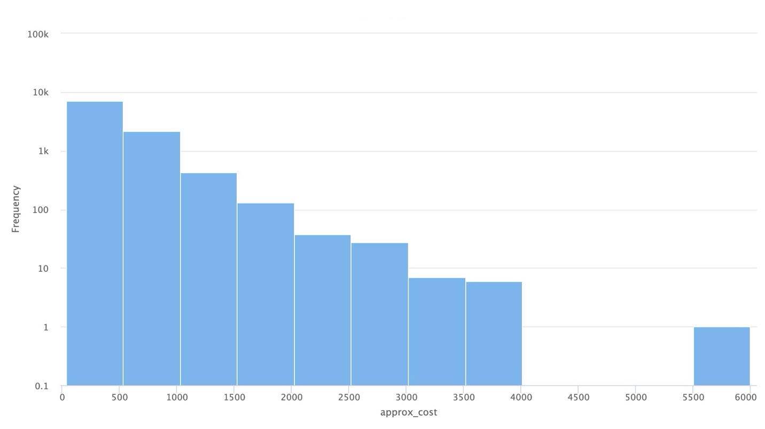
Figure 1: Avg Cost vs Frequency
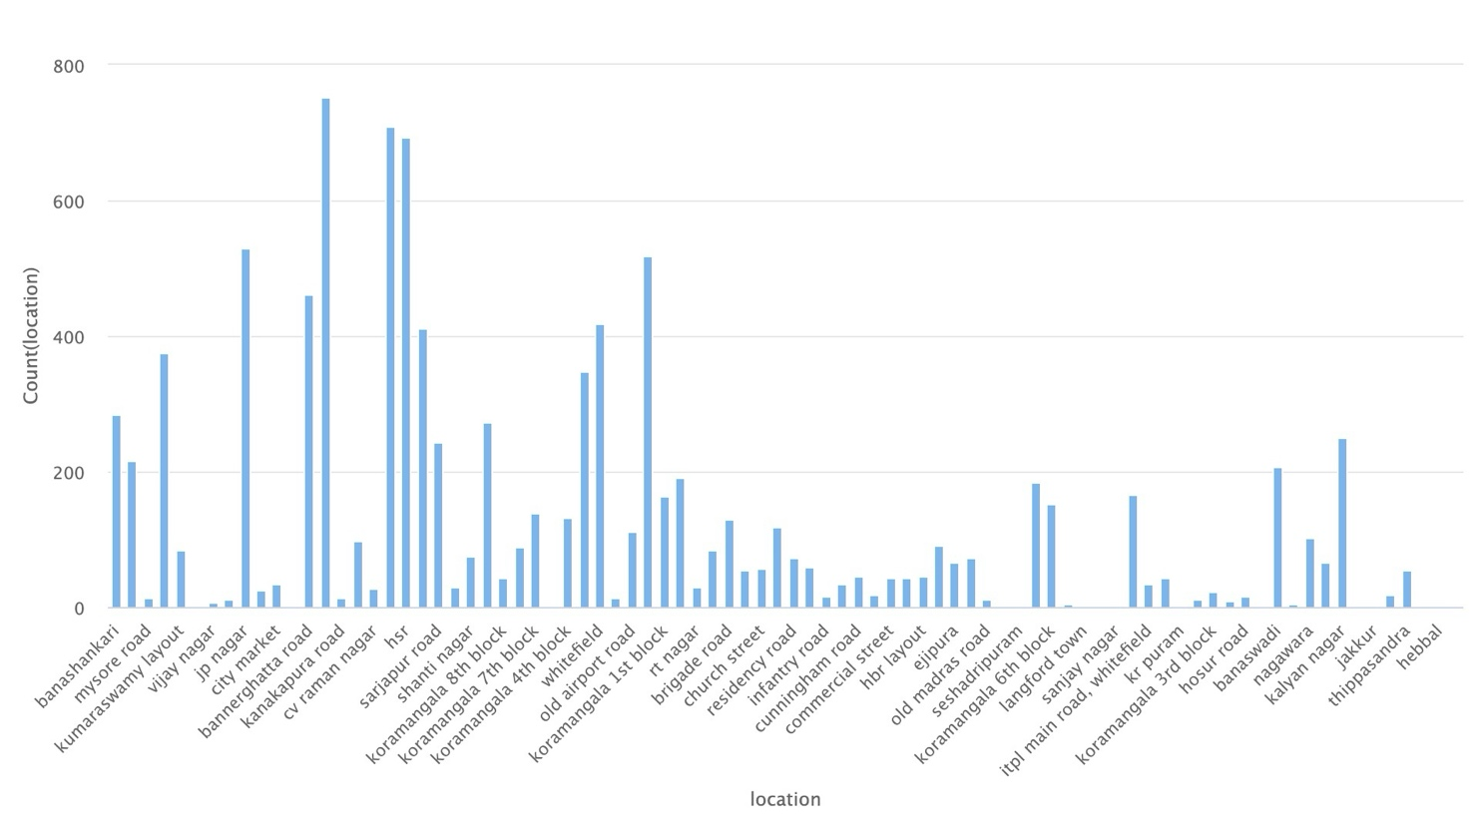
Figure 2: Location vs Frequency

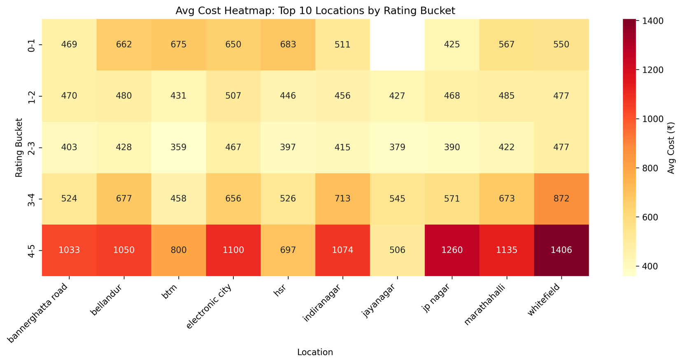
Figure 3: Heatmap of Location vs Rating
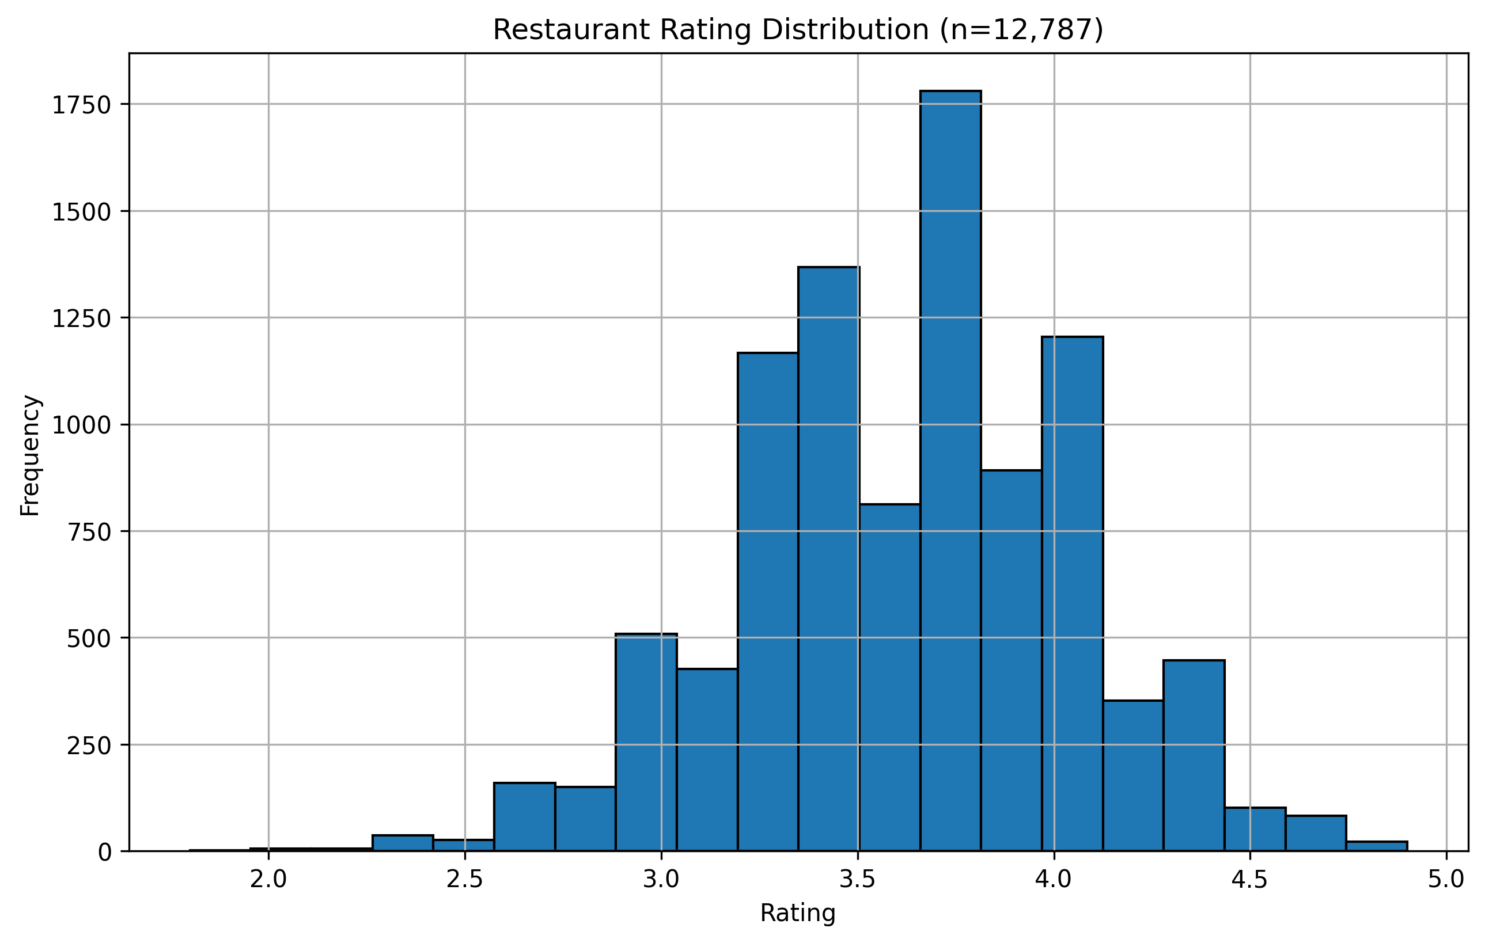
Figure 4: Rating vs Frequency

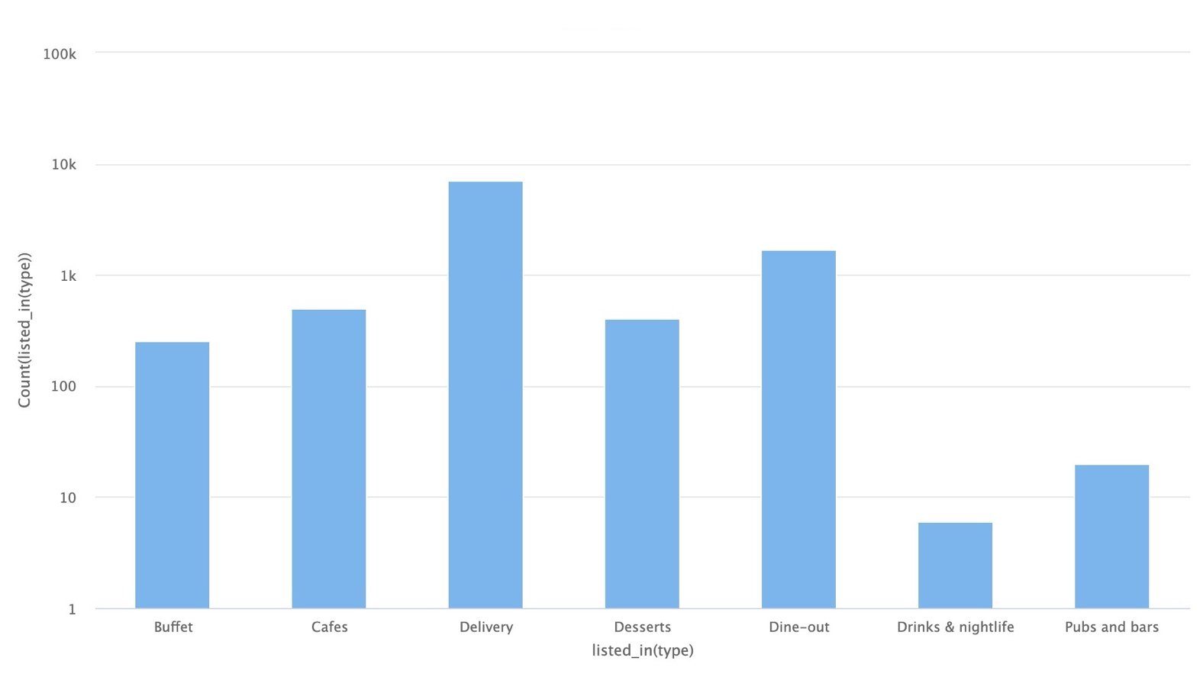
Figure 5: Restraunt Type vs Frequency
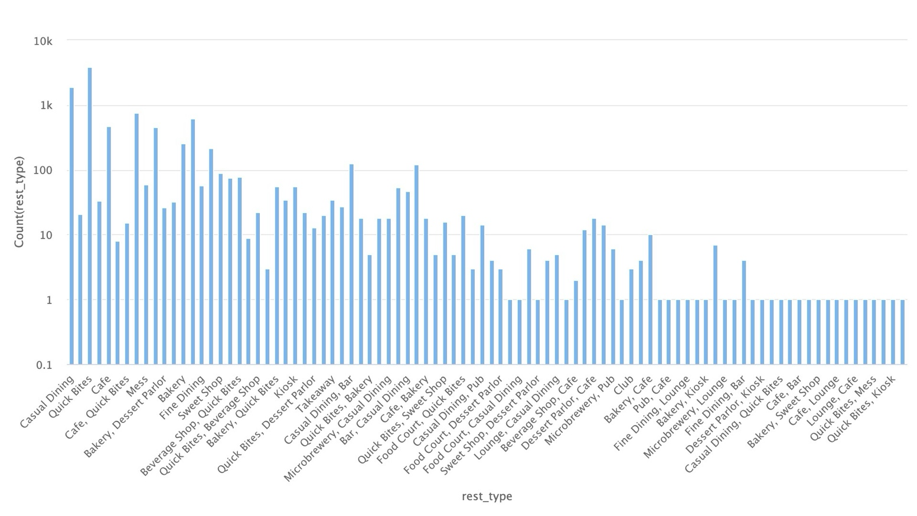
Figure 6: Dishes vs Frequency

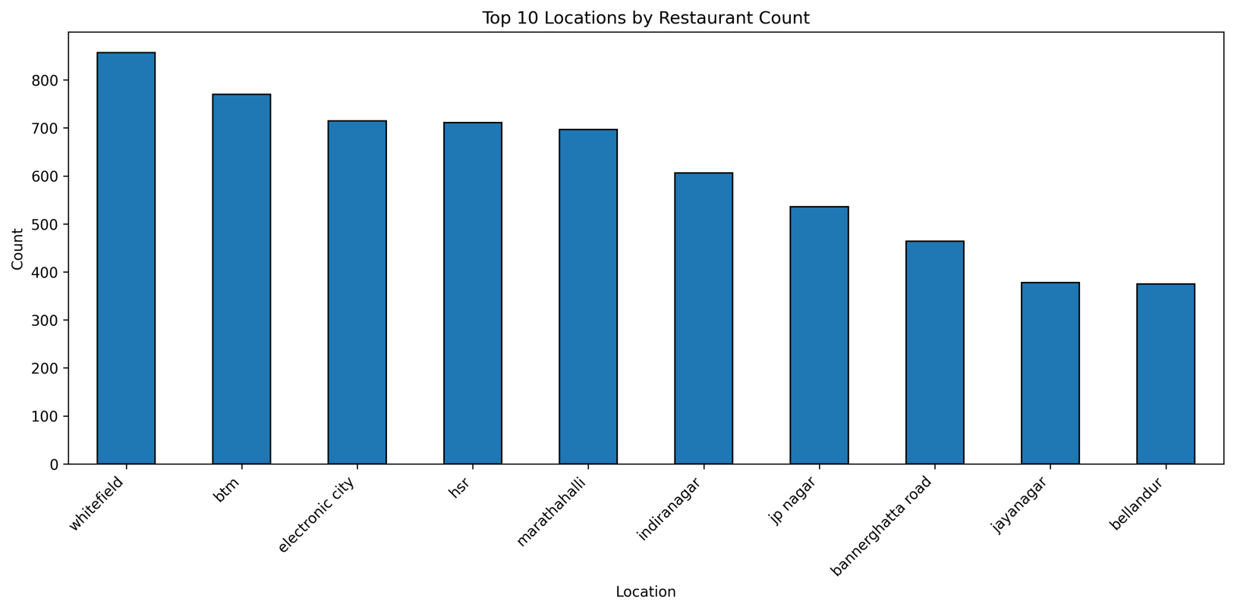
Figure 7: Location vs Frequency

Pre-Processing Pipeline
Raw → Clean Transformation: 51,717 rows × 17 cols → 12,787 rows × 12 cols

Cleaning Steps Applied:
1. DROP Columns (High Missing/Non-Essential):
- disliked (54.29% missing → dropped)
- phone (2.34% → dropped, not needed)
- url, address, reviewslist, menuitem (irrelevant for TF-IDF)

2. RATE Cleaning (15.03% missing):
- "4.1/5" or "NEW" → NaN → Filled median(3.8) or dropped
- Result: Numeric ratings ready for sorting

3. APPROX_COST (0.67% missing):
- "1,000" → 1000 (remove commas)
- "₹800-1000" → Median(900)
- Fill missing: Dataset median (~800)

4. TEXT for TF-IDF ("soup" feature):
- cuisines: "north indian, biryani" → "north indian biryani"
- location: "BTM Layout" → Lowercase
- rest_type: "Casual Dining" → Combined
- Drop 45 rows (0.09%) with empty cuisines

5. DUPLICATES: Removed 1,200+ exact matches

Before/After Comparison:
| Metric | Raw | Clean |
|-----------------|-------------|-------------|
| Rows | 51,717 | 12,787 |
| Columns | 17 | 12 |
| Missing Rate | 5.2% avg | <1% |
| Ready for Model | No | Yes (TF-IDF)|

Output: data/zomato_clean.csv → Loaded by content_based.py
[Screenshot: df.head()]
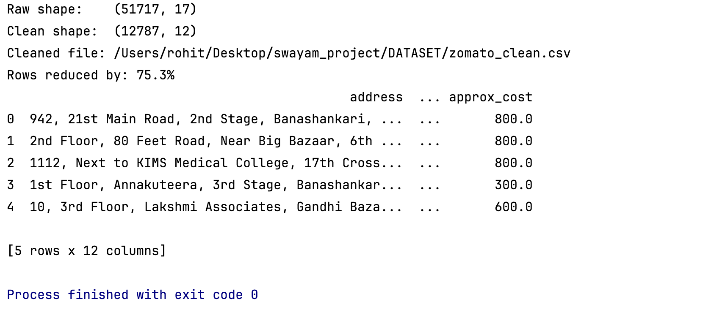
Figure 8: Console Output [df.head()]

